**Custom Training of Clarifai**

**Hongkun Jin**

Goal: Build and train a custom model that can accurately categorize common aviation imagery.

Custom concepts to be trained:

Dribbling, Dunk, Freethrows, Shooting

Step 1: Create an Application and Explore the UI

API calls (operations) are tied to an account and application.

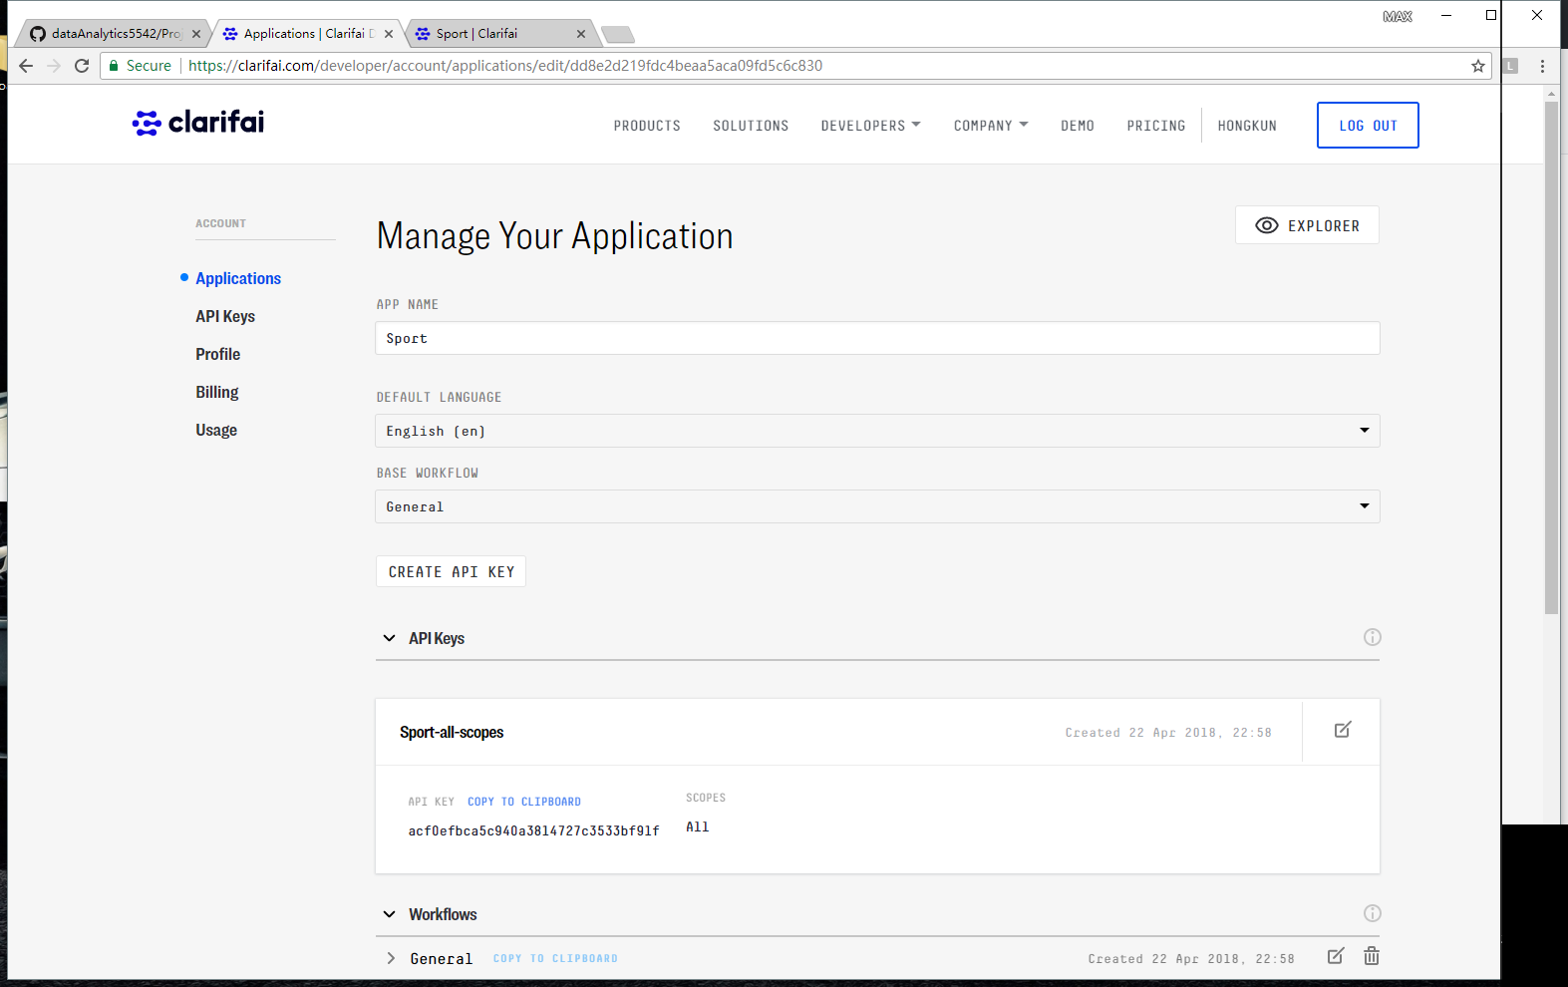

(sport.png)

Step 2: Add images to application

Custom models are built by training on our own data. The model will be able to make predictions specific to my own unique content and context.

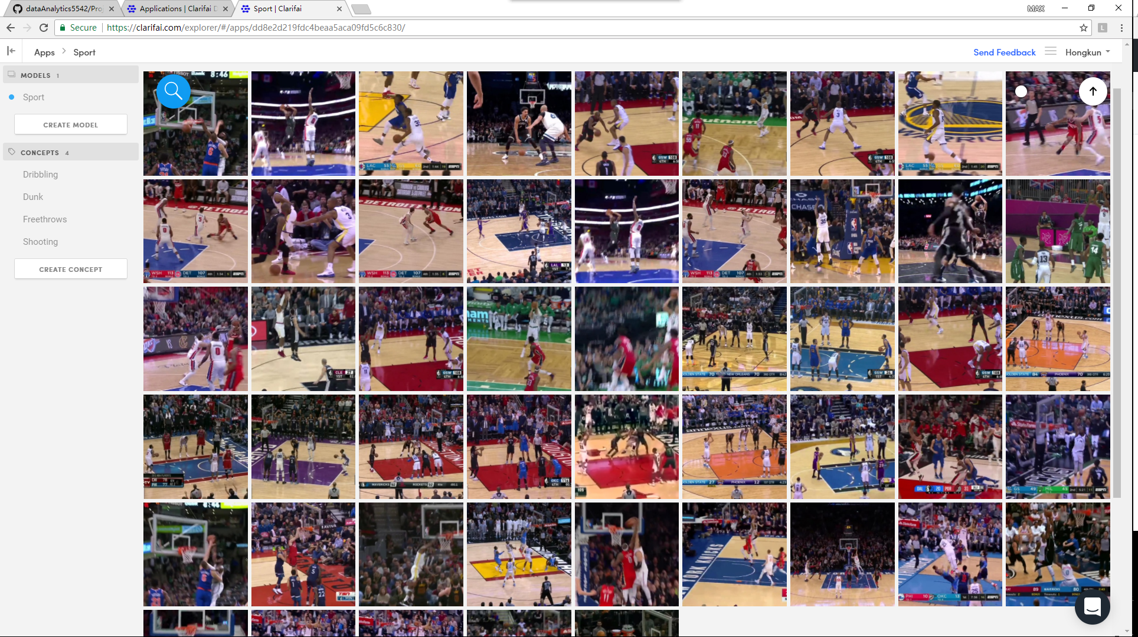

(importimages1.png)

Step 3: Adding the first concept to those images

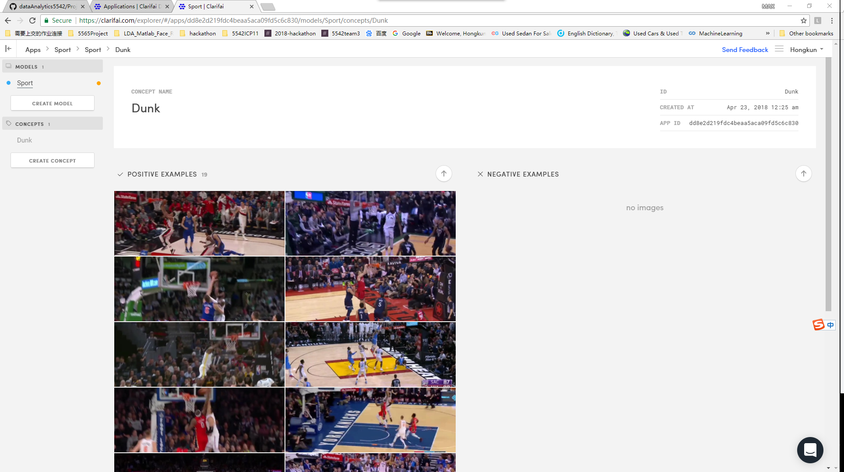

(firstConcept1.png)

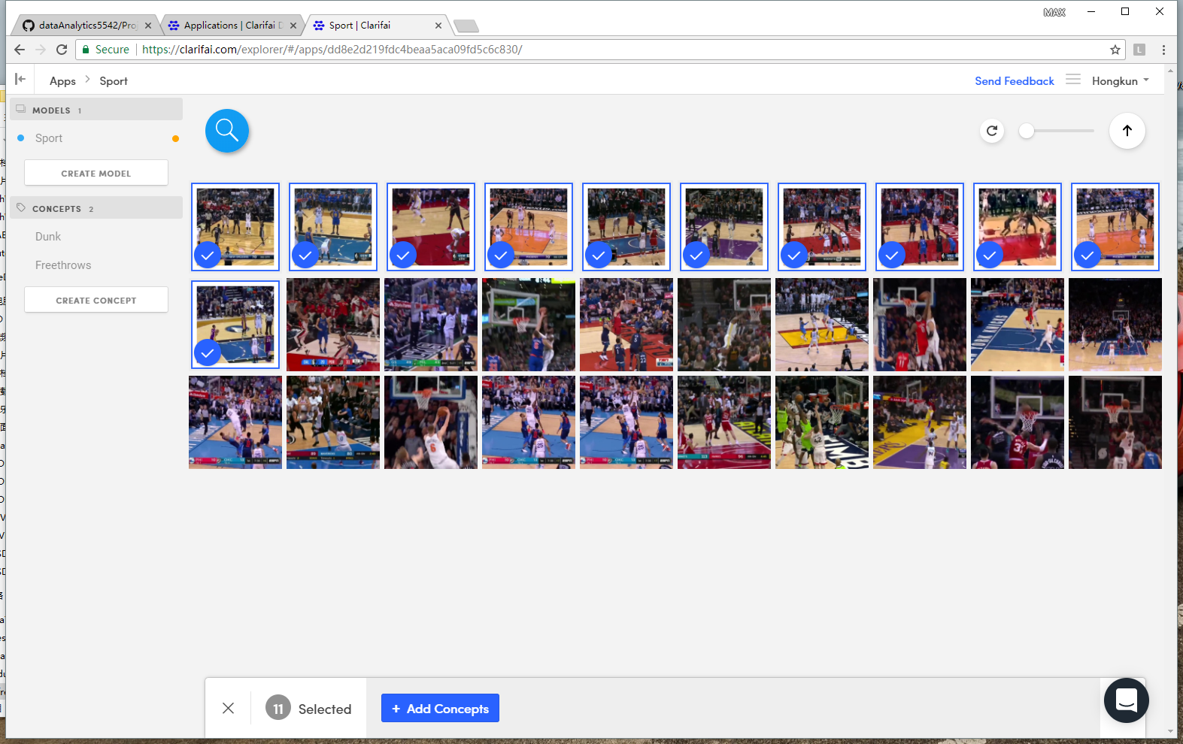

(fristconcept2.png)

Step 4: Provide negative examples for that concept ('jet engine')

A robust and well performing concept is made up of both positive and negative examples.

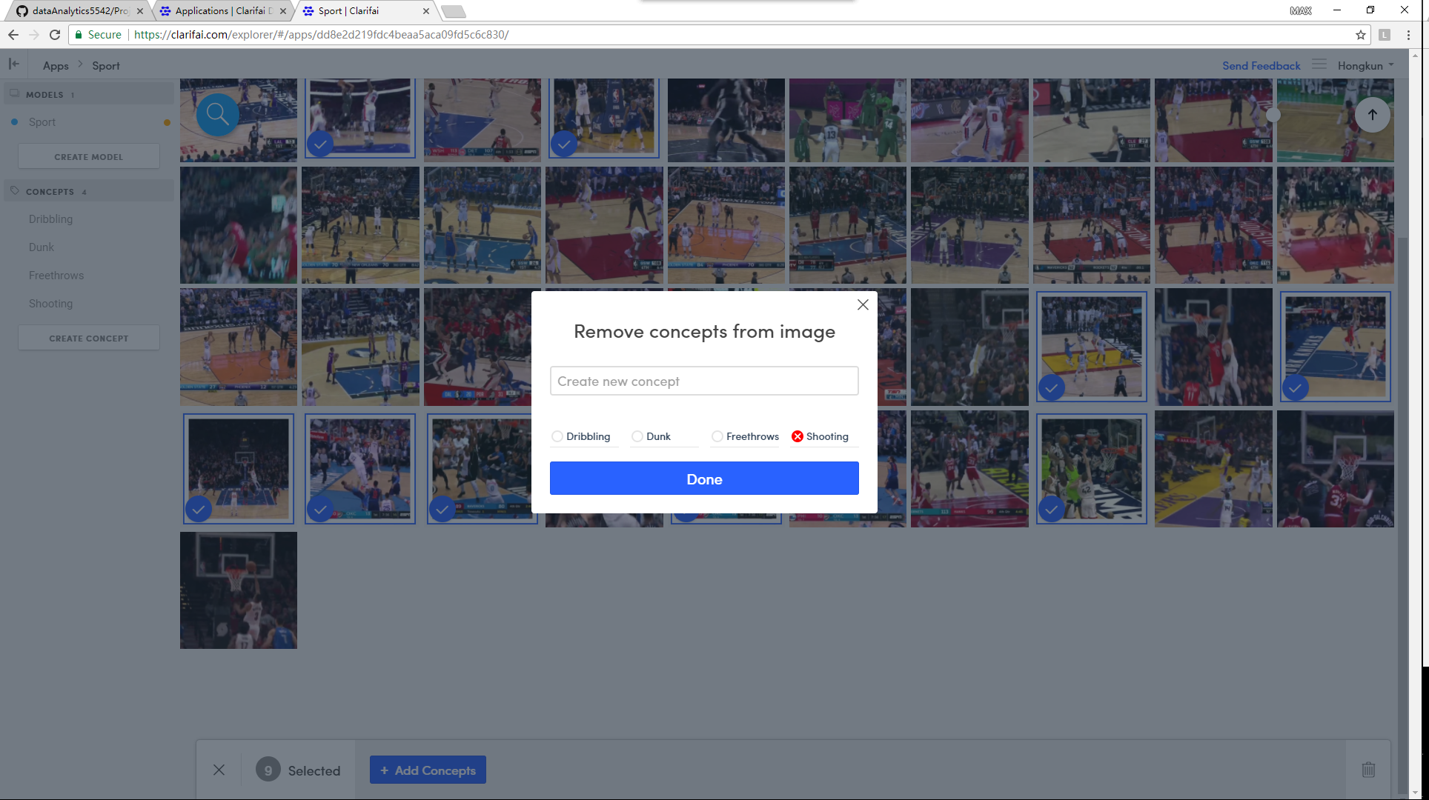

(NS1.png)

Step 5: Adding additional concepts to the model

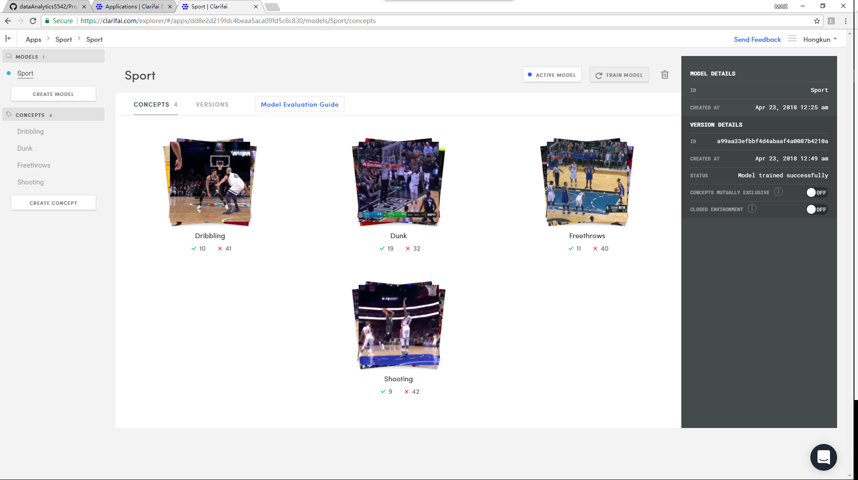

(train2.png)

Step 6: Observe the model predictions and updates in real-time

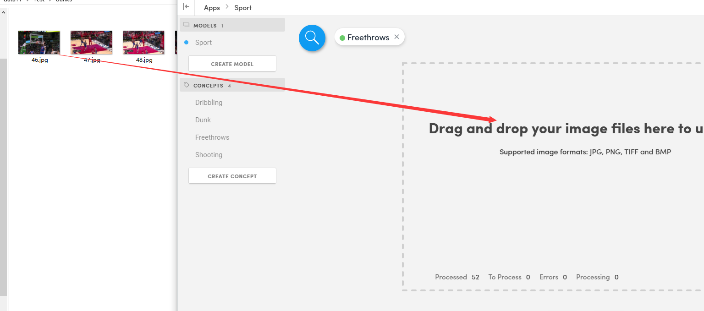

(test1.png)

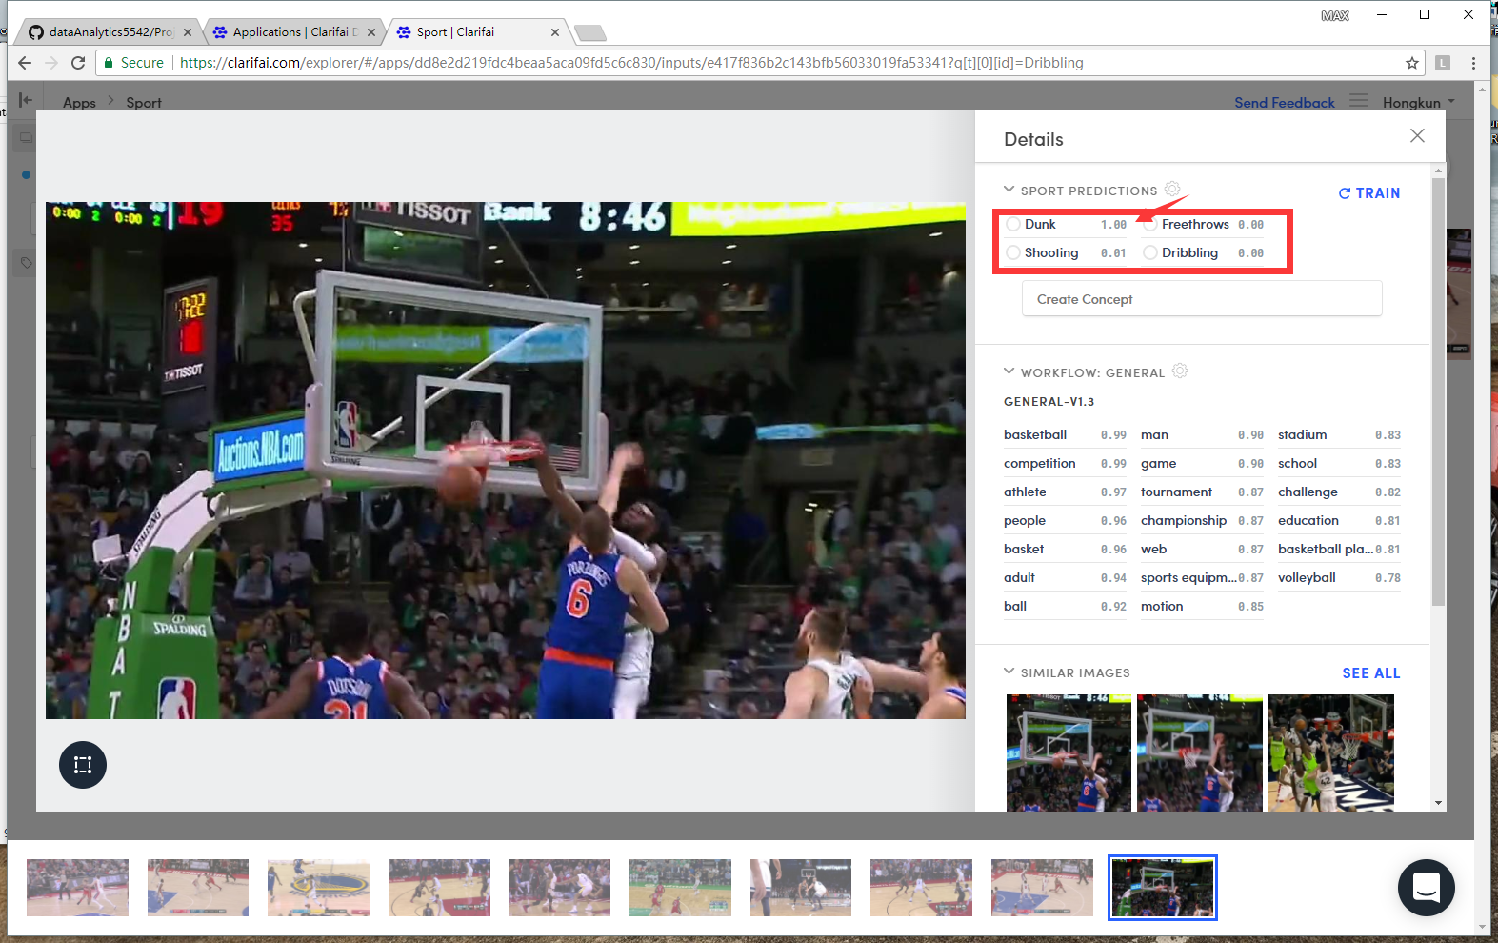

(test2.png)

Step 7: View model details

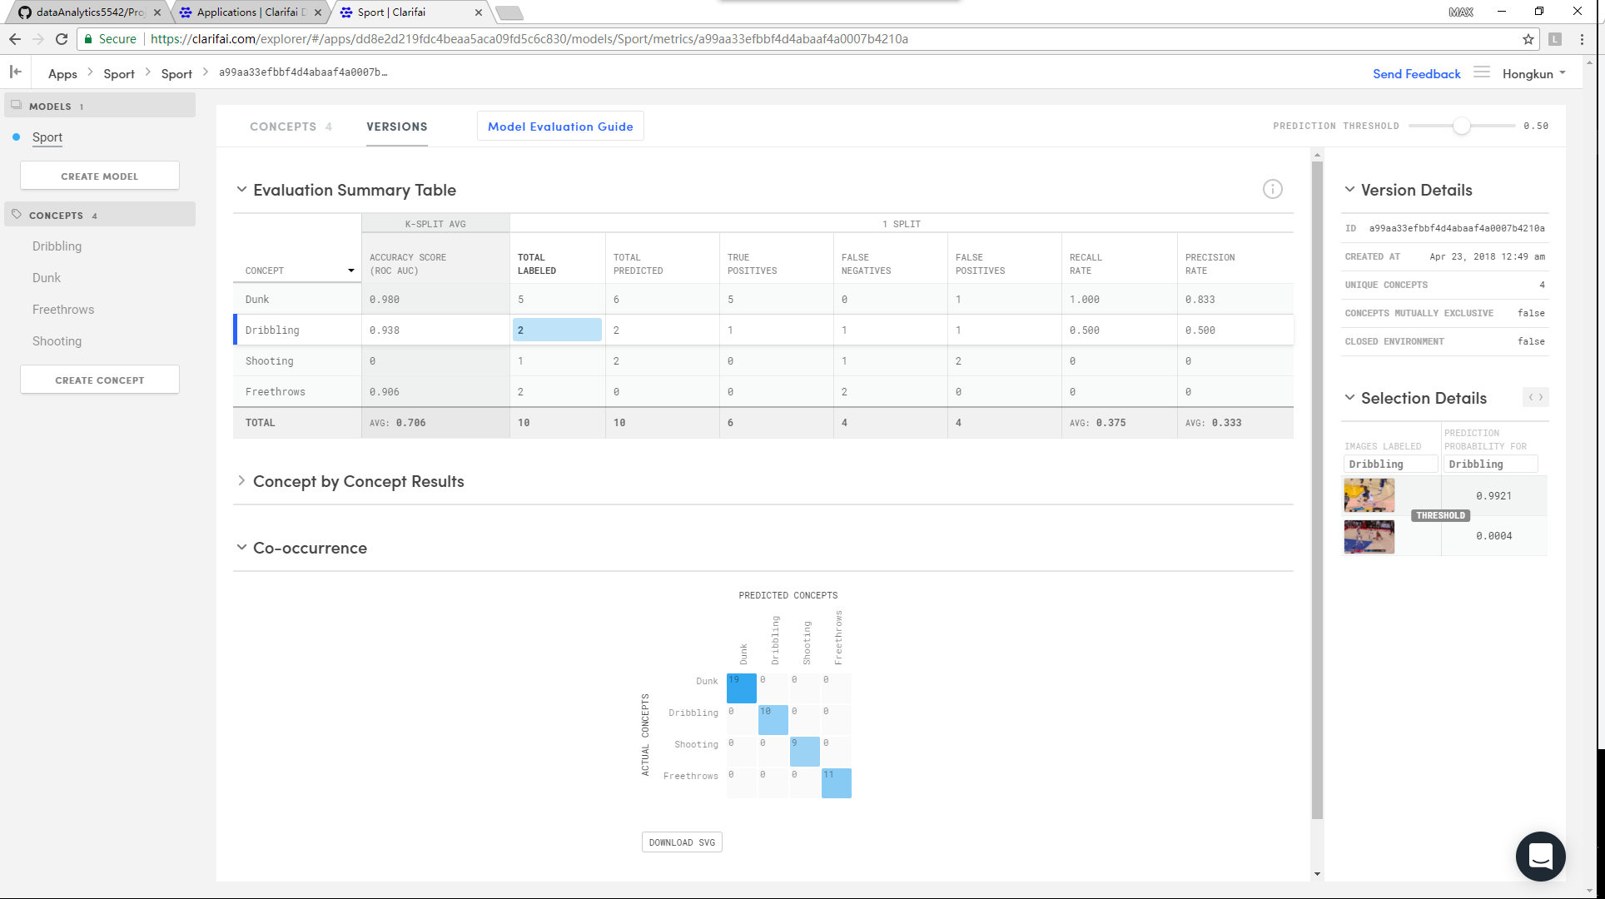

(trainingPart1.png)

This is the model performance after custom training.